ABAP
Mini Project
Event Management

Document Control

Table of Contents
Reference No:
Security Classification: | Capgemini Internal
Updated Doc Date: | 10.02.2020
Author(s): | Name |  | Title
Author(s): | Upendar Reddy N |  | Trainer
Reviewer(s): | Name |  | Title
Reviewer(s): | Vandana Mistry |  | Deputy Manager
Issuer(s): | Name |  | Title
Issuer(s): | Vandana Mistry |  | Deputy Manager
Issuer Signature(s):
Distribution: | Name |  | Title
Document History: | Date | Revision | Change
Document History: | Nov, 2017 | 1.0 | Document creation
1 Introduction 4
1.1 Setup Checklist for Mini Project 4
1.2 Instructions 4
2 Problem Statement 5
2.1 Objective 5
2.2 Abstract of the project 5
3 Implementation in SAP/ABAP LOT 6
3.1 Summary of the functionality to be built: 6
3.2 Objective 6
3.3 Assumptions 6
3.4 Flow chart 7
3.5 Tables 8
3.6 Screens 8
3.7 Screenshots 8
3.8 Performance Logic 21

Introduction

This document outlines a mini project for the ABAP.
This document contains the work flow of the system and gives guidelines on how to build the functionality gradually in each of the course modules of the ABAP.

Setup Checklist for Mini Project
Minimum System Requirements
- Intel Pentium 90 or higher (P166 recommended)
- Microsoft Windows 95, 98, or NT 4.0, 2k, XP, Windows 2007.
- Memory: 32MB of RAM (64MB or more recommended)
- Internet Explorer 6.0 or higher
- Oracle 9i client and access to oracle 9i server or SQL Server Client and access to SQL Server
- Conenctivity to SAP Server

Instructions
- The code modules in the mini project should follow all the coding standards.
- Create a directory by your name in drive <drive>. In this directory, create a subdirectory MiniProject. Store your Project here.
- You can refer to your course material.
- You may also look up the help provided in the SAP docs and documentation provided with SAP.

Problem Statement

Objective
Development of a Application For Event Management System.

Abstract of the project
The project is to develop Application For Event Management System.

- Event Management application provides a user friendly application to organize an event.
- It provides the user to choose the events they want to organize from the list of event provided within the application.
- It provides the Admin to view the list of events booked.
- Allows the User to organize their events according to their need .
- Updates in the amenities provided can be done by the admin only.
- For every event booked a unique Invoice id is generated.
- User can book the events through online transaction.
- Generates an Invoice with the details of the event that is booked for after the booking process is completed.

Technology used:
- Oracle 12c (Database)
- SAP ABAP

Implementation in SAP/ABAP LOT

Summary of the functionality to be built:
The participants need to develop the System for Event Management by building the functionality incrementally in each of the course modules of SAP LOT.
The project mainly focuses on developing an application to book an event with flexible payment option in the application itself.
Abstract:

- Event Management System provides detailed information about the events that can be organized.
- It allows the admin to add, update, delete all types of the events.
- For every transaction there is a unique invoice id provided.
- Updates of application can be done by admin.
- It allows the users to book the event based on their registered details.
- User details are recorded along with their orders.
- Allows the user to book the event using online transaction.
- Generates booking details form after the booking is done.
Problem Statement:

The project aims to implement Event Management System.
in SAP by building the functionality that easey to customers to book an events for the any occations.
Agenda:
This project aims at development of an Event Management System Utility which facilitates the users to book the event, and the admin to add, update and delete the properties in user friendly manner.
The admin should login the application to add, update, delete the event details.
The Users should register on the server for getting access to the event details and query result retrieval.

Objective
To create a Event Management System.
- To save the time and resources.
- Improved services through greater access to accurate information.
- To keep the data secure.
- To make the system user friendly.

Note: Mni Project Should Cover the Below Topics:
- Module Pool – Need to Cover all the Concepts
- Reports (ALV/OOALV).
- Forms (Smartforms and Adobe Forms).
- Data Upload (BDC Session Metod).

Assumptions
- Event management cannot be done for two or more days.
- Bank account details cannot be validated.
- Cancellation system is not included.

Flow chart
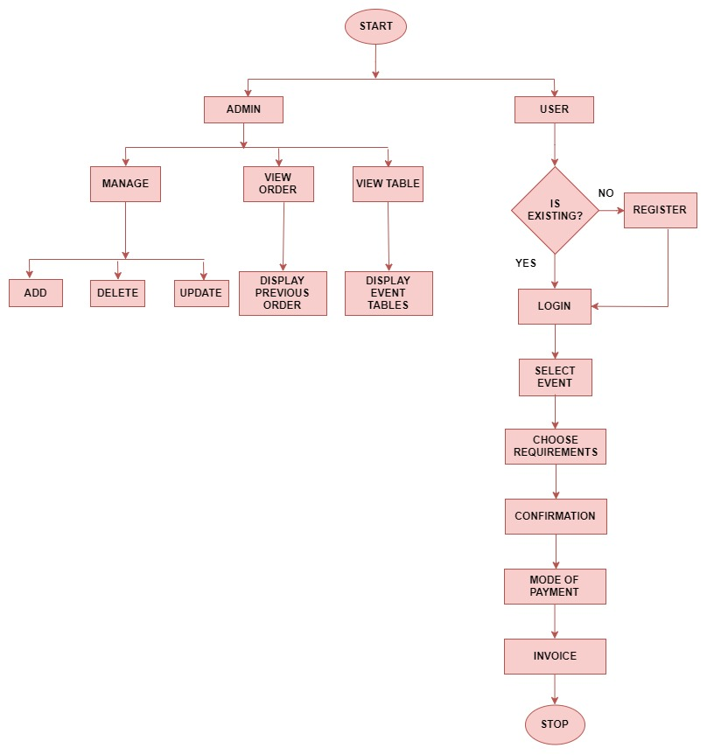

Tables
S. No | Table Name | Description
1 | ZXXX_ADMIN | ADMIN MASTER
2 | Z XXX_USER | USER MASTER
3 | Z XXX_CULTURAL | CULTURAL EVENT TABLE
4 | Z XXX_PROMOTION | PROMOTIONAL EVENT TABLE
5 | Z XXX_WEDDING | WEDDING EVENT TABLE
6 | Z XXX_BIRTHDAY | BIRTHDAY EVENT TABLE
7 | Z XXX_SPORTS | SPORTS EVENT TABLE
8 | Z XXX_INVOICE | INVOICE TABLE
9 | Z XXX_BANKING | BANK MASTER
10 | Z XXX_NET_BANK | NET BANKING TABLE

Screens
- Application home screen
- Admin and user login screen
- User login screen
- New user registration screen
- List of Events
- User settings
- Cultural event screen
- Promotional event screen
- Wedding event screen
- Sports event screen
- Birthday event screen
- Invoice Screen
- Mode of payment screen
- Net banking validation screen
- Types of bank screen
- Card details screen
- Form printing screen
- Input parameters screen
- Form screen
- Admin login screen
- Admin edit profile screen
- Admin screen
- Cultural event managing screen
- View cultural table screen
- Promotional event managing screen
- View promotional table screen
- Birthday event managing screen
- View birthday table screen
- Wedding event managing screen
- View wedding table screen
- Sports event managing screen
- View sports table screen
- Track orders screen
- View tables screen

Screenshots
- Home Screen

This screen shows application home page, where the user needs to select the push button called “START THE APPLICATION”.

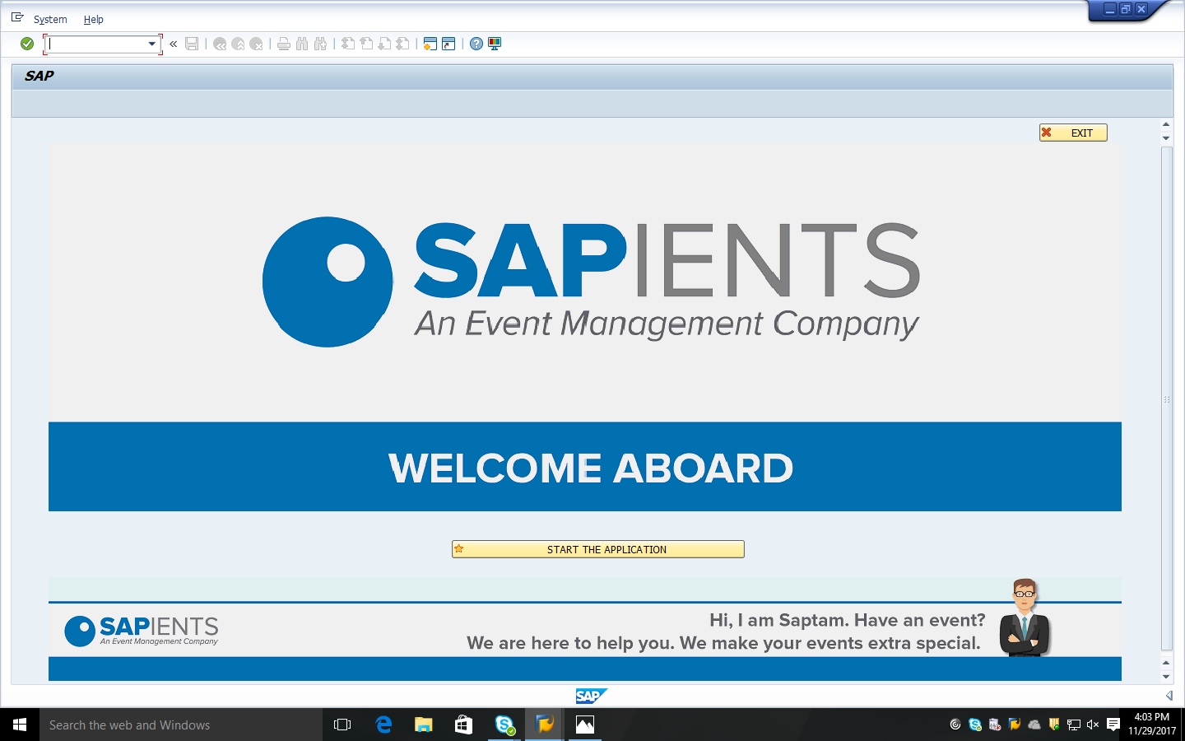

ADMIN AND USER LOGIN SCREEN:
This screen shows admin and user login page. If a person is a user, then he/she have to select the “USER” pushbutton. Admins are only few authorized persons. The user cannot view the application without registering his/her account.

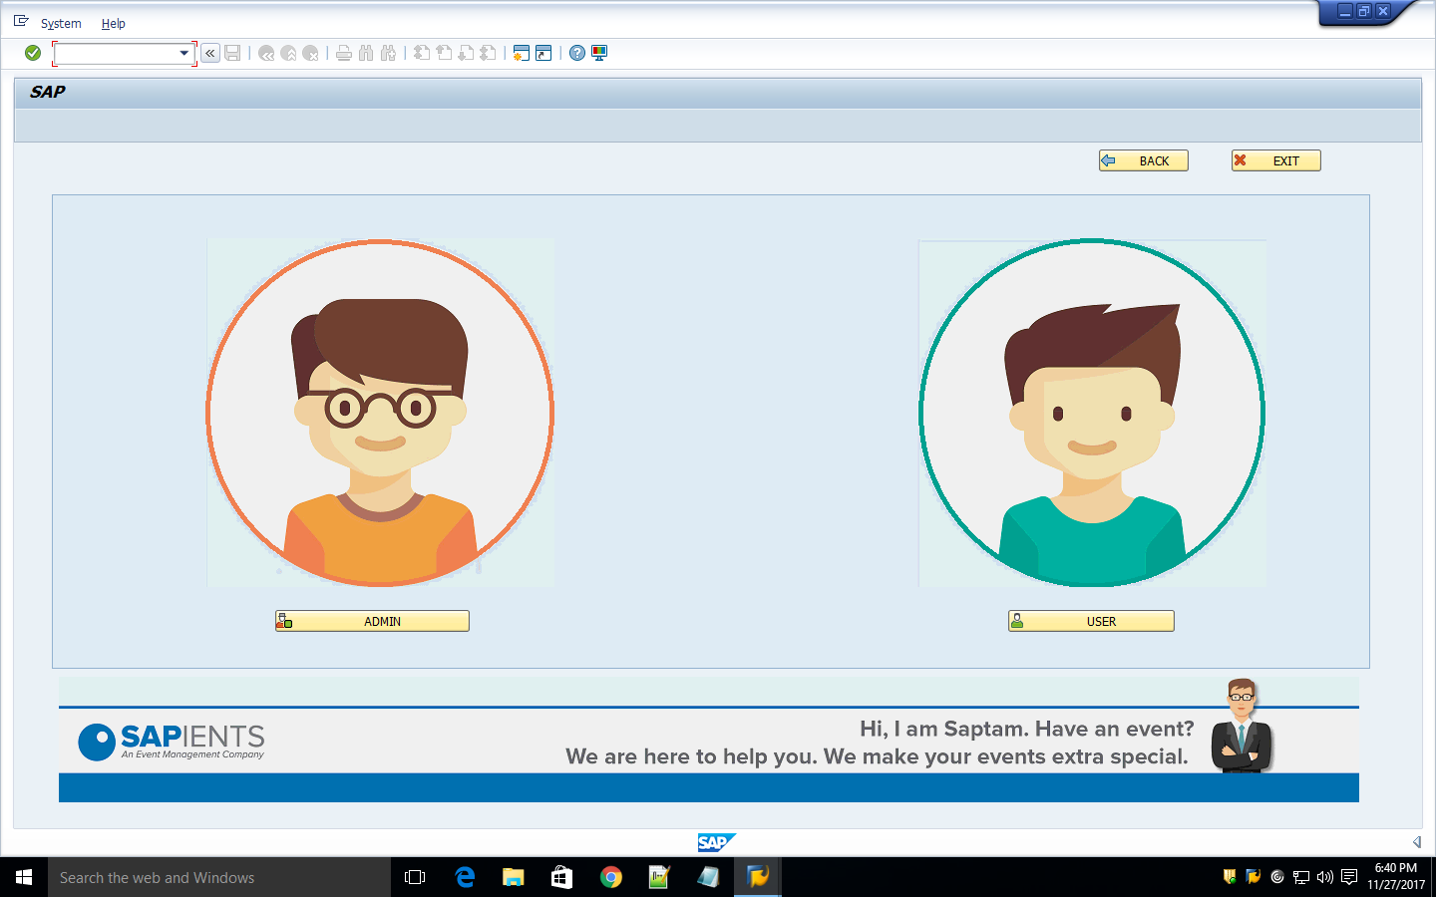

- Login Screen
This screen shows the user login page. If the user is already existing user, he/she should login with their credentials. If the user is not registered here, he/she should register by selecting the “NEW USER” pushbutton.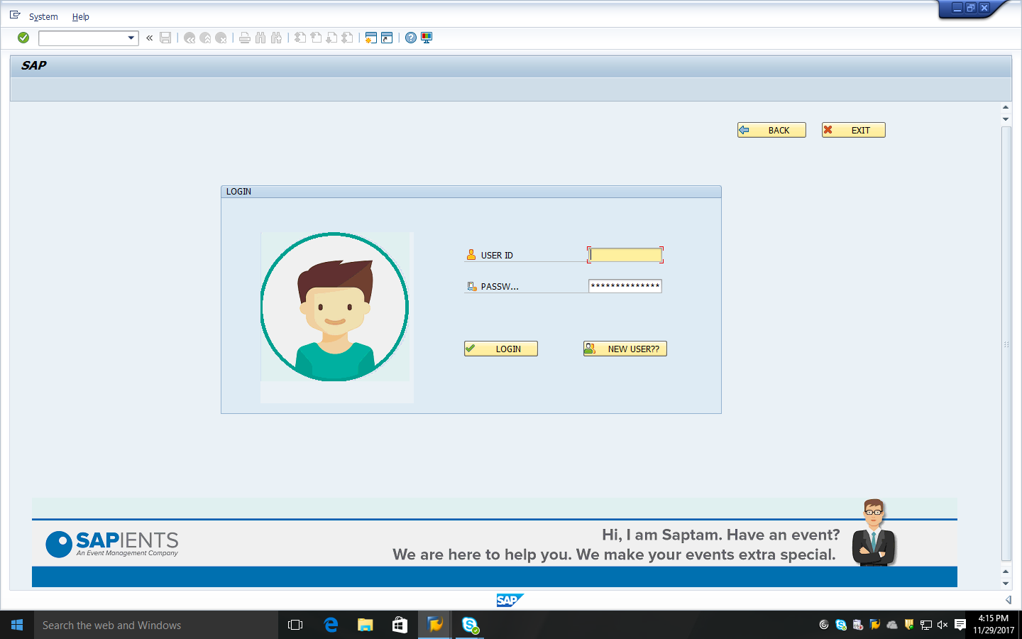

Login screen is same for admin, user and organization. By entering credentials anyone can login to the system.

- Admin Screen
After Admin login, he/she can perform operations in system like management of user accounts, managing posts, managing users etc.

- Registration Screen
- This screen shows the user registration page. If the user is not registered before he/she can register here by giving their details like User Id, Password, Age, Address, Mobile Number and Email Id. These values are automatically stored in the database table in the backend.

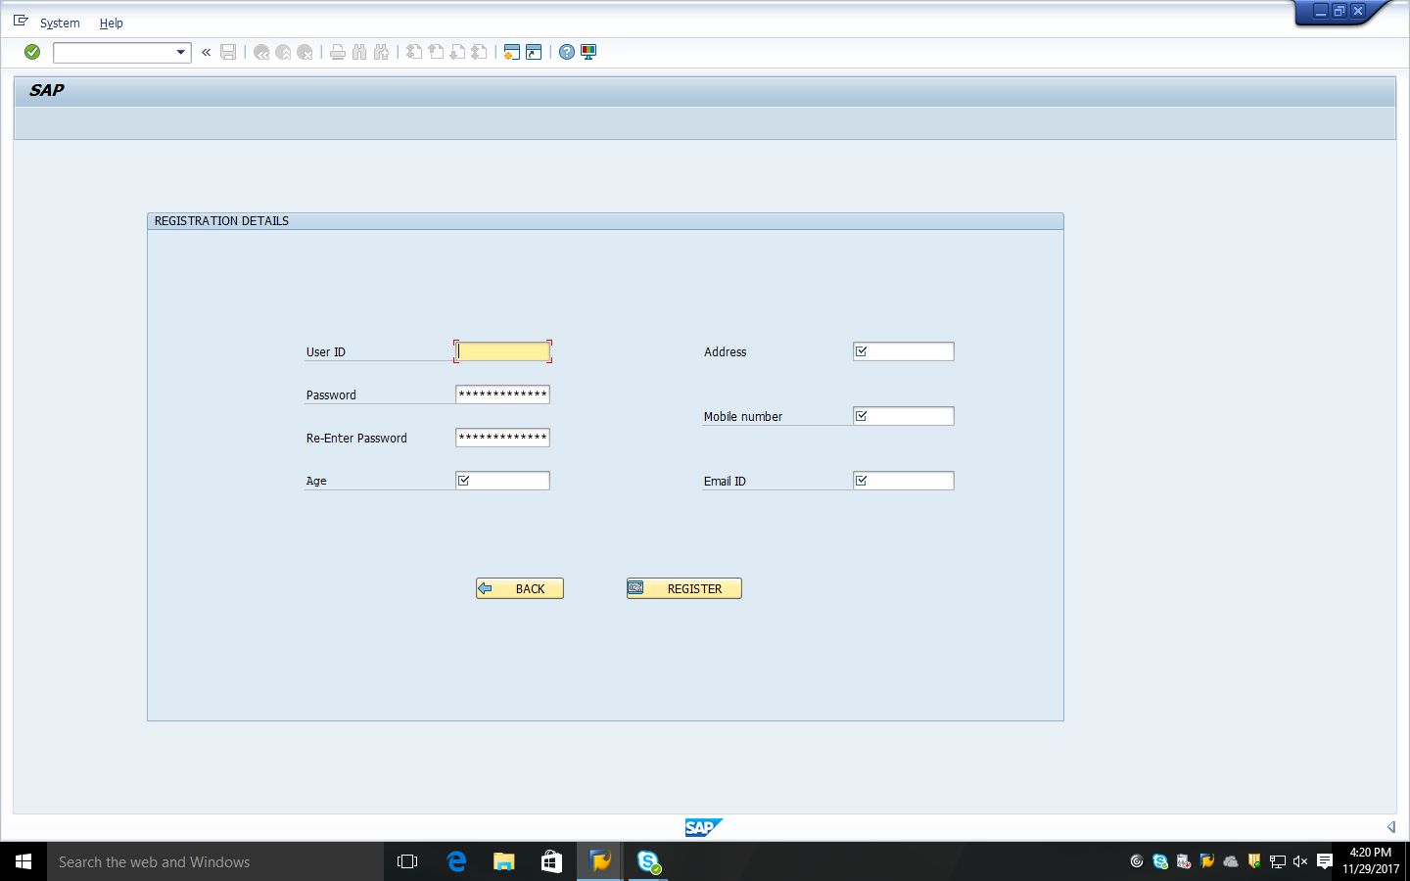

LIST OF EVENTS:
Once the user logs in the application he will be redirected to this screen, showing all the list of events that are provided. List of events are Cultural, Promotional, Wedding, Sporting and Birthday Events.
In this screen, there are options for User Settings and Logout.
User Settings- User clicks on this option, If the user wants to update and view his details.
Logout- User clicks on this option, If he/she wants to logout from this application.
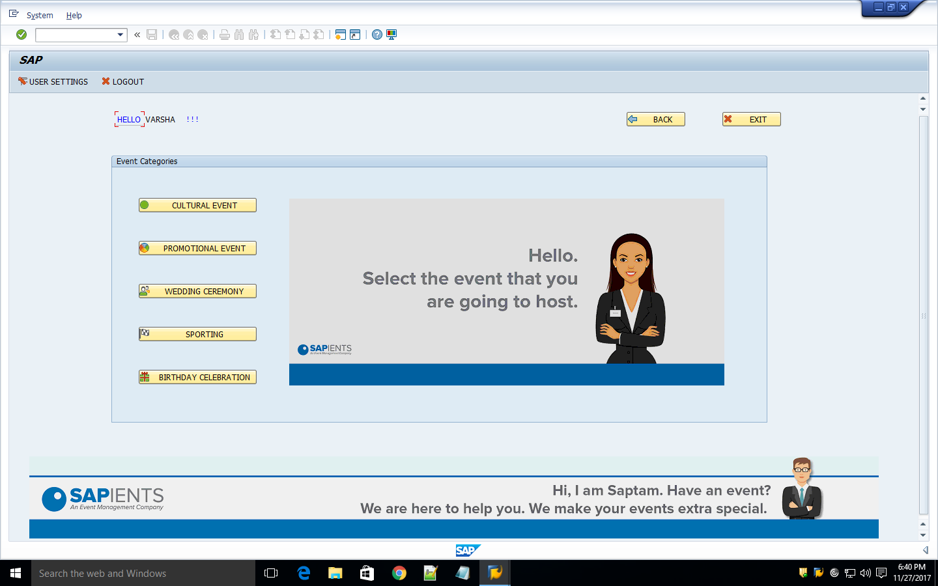

USER SETTINGS:
The user can update and view his details by using this option called “USER SETTINGS”. Any changes made in this fields will directly upload into the database table.
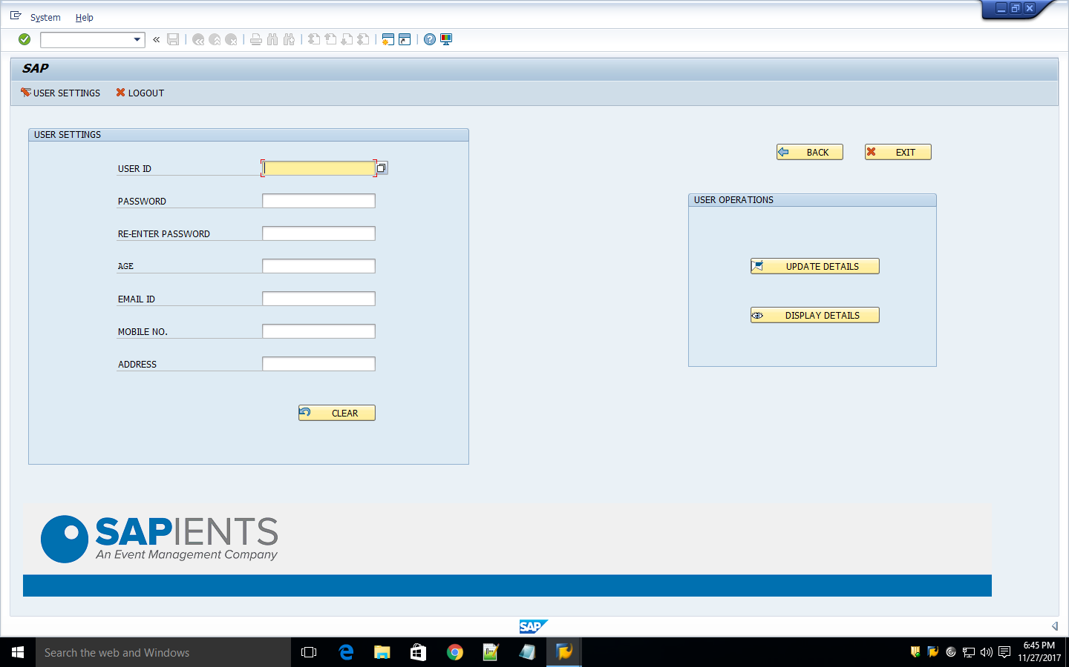

CULTURAL EVENT SCREEN:
The above screen displays the cultural event screen. User can find the list of amenities and costs according to the amenities and the description of each amenity.
The user has to provide the event date on which he/she is going to host the event. From time and To time are also to be provided by the user according to the requirement.
Few customizations can be done by the user by selecting the amenities like No of Chairs, No of Microphones, No of Sound box and No of Water pouches according to his/her choice. Once the user enters all this things, he/she can calculate the total amount which includes other amenities cost namely decoration, advertisement, photography and medical assistance.
The next step of the user is to click on the Checkout option for his/her details to be populated.

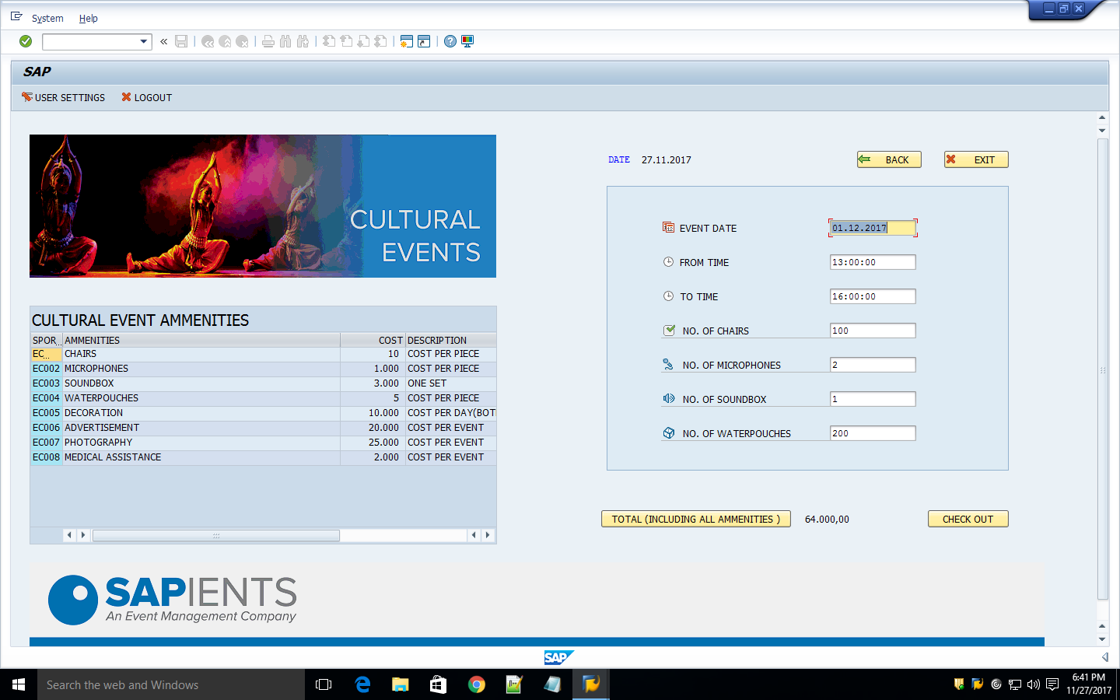

PROMOTIONAL EVENT SCREEN:
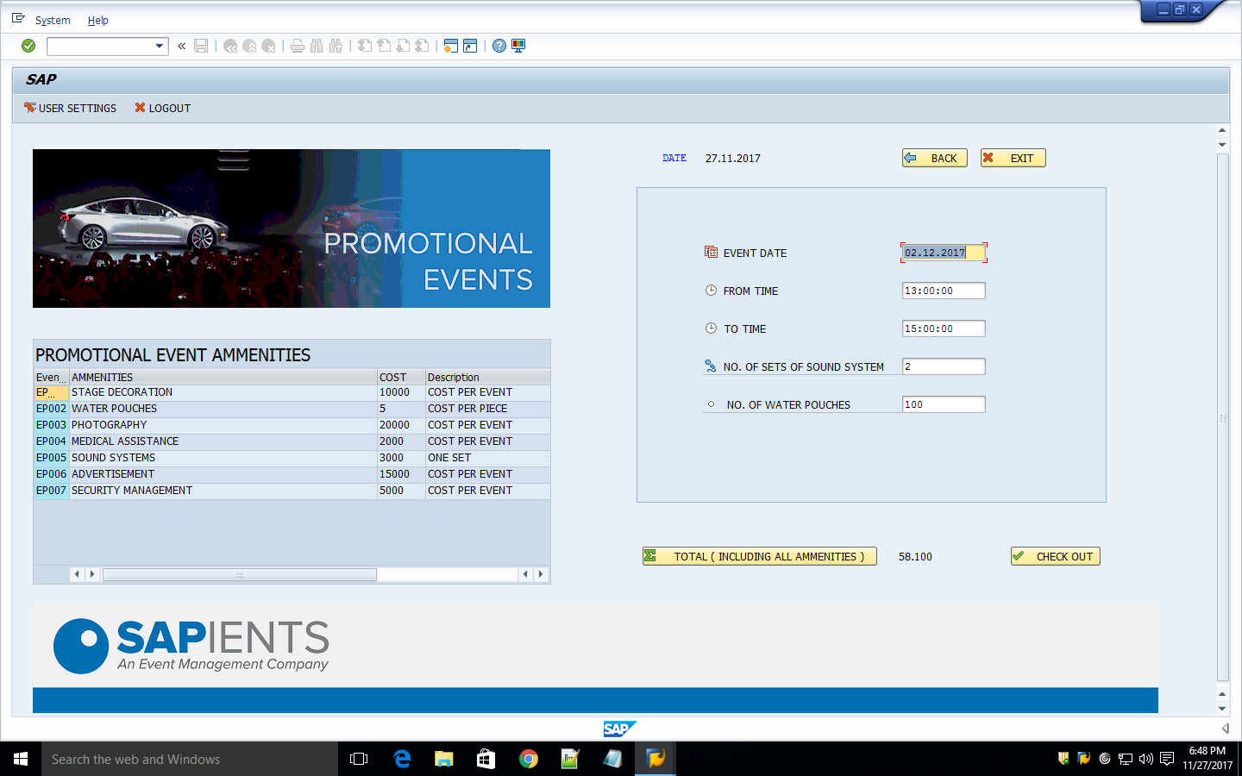

The above screen displays the promotional event screen. User can find the list of amenities and costs according to the amenities and the description of each amenity.
The user has to provide the event date on which he/she is going to host the event. “From time” and “To time” are also to be provided by the user according to the requirement.
Few customizations can be done by the user by selecting the amenities like No of Sets of Sound System and No of Water pouches according to his/her choice. Once the user enters all this things, he/she can calculate the total amount which includes other amenities cost namely Security management, advertisement, photography and medical assistance.
The next step of the user is to click on the Checkout option for his/her details to be populated.

WEDDING EVENT SCREEN:
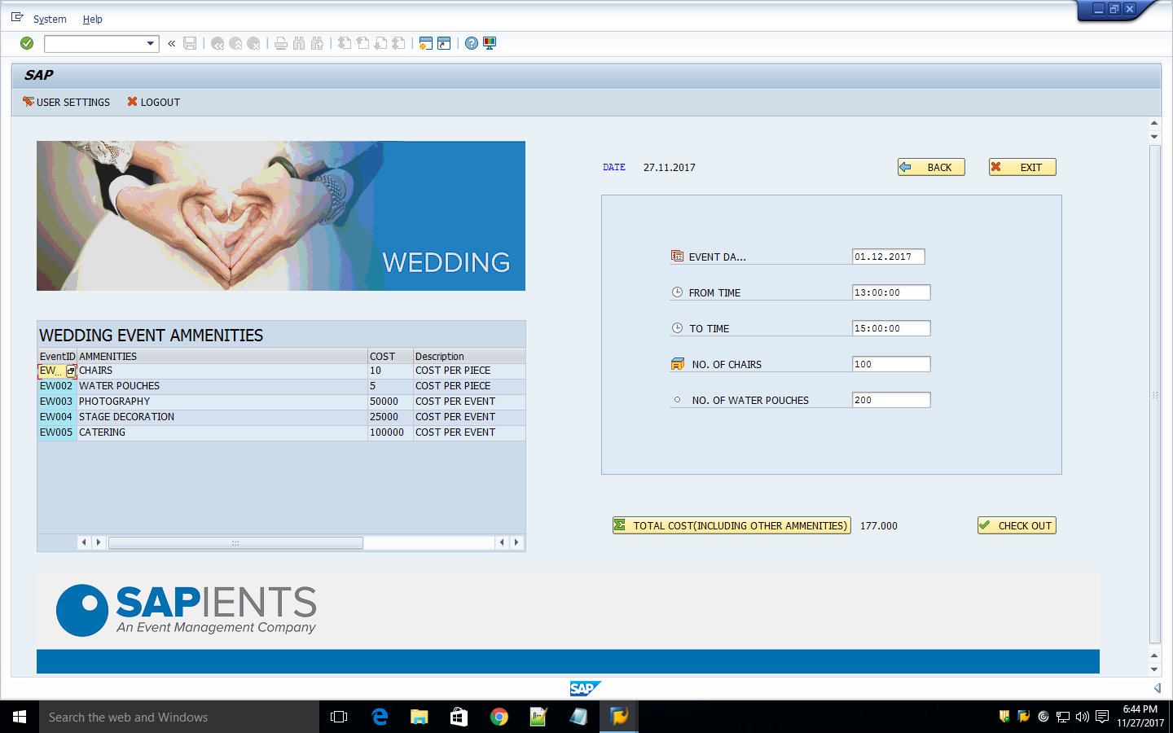

The above screen displays the wedding event screen. User can find the list of amenities and costs according to the amenities and the description of each amenity.
The user has to provide the event date on which he/she is going to host the event. From time and To time are also to be provided by the user according to the requirement.
Few customizations can be done by the user by selecting the amenities like No of Chairs and No of Waterpouches according to his/her choice. Once the user enters all this things, he/she can calculate the total amount which includes other amenities cost namely decoration, advertisement, photography and medical assistance.
The next step of the user is to click on the Checkout option for his/her details to be populated.

SPORTS EVENT SCREEN:
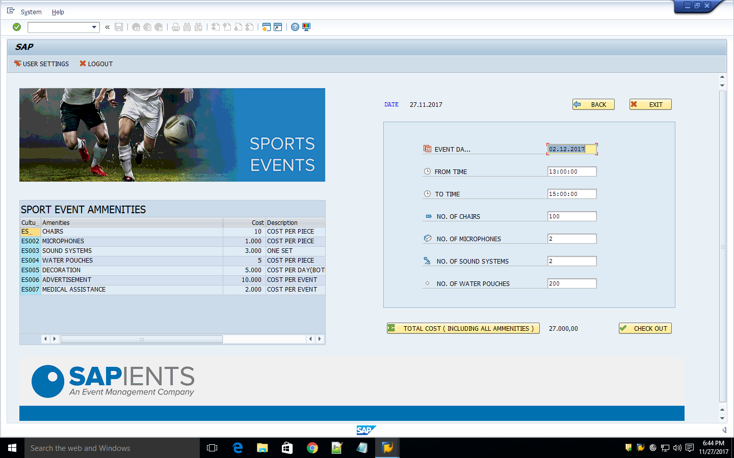
The above screen displays the sports event screen. User can find the list of amenities and costs according to the amenities and the description of each amenity.
The user has to provide the event date on which he/she is going to host the event. From time and To time are also to be provided by the user according to the requirement.
Few customizations can be done by the user by selecting the amenities like No of Chairs, No of Microphones, No of Soundbox and No of Waterpouches according to his/her choice. Once the user enters all this things, he/she can calculate the total amount which includes other amenities cost namely decoration, advertisement, photography and medical assistance.
The next step of the user is to click on the Checkout option for his/her details to be populated.

BIRTHDAY EVENT SCREEN:
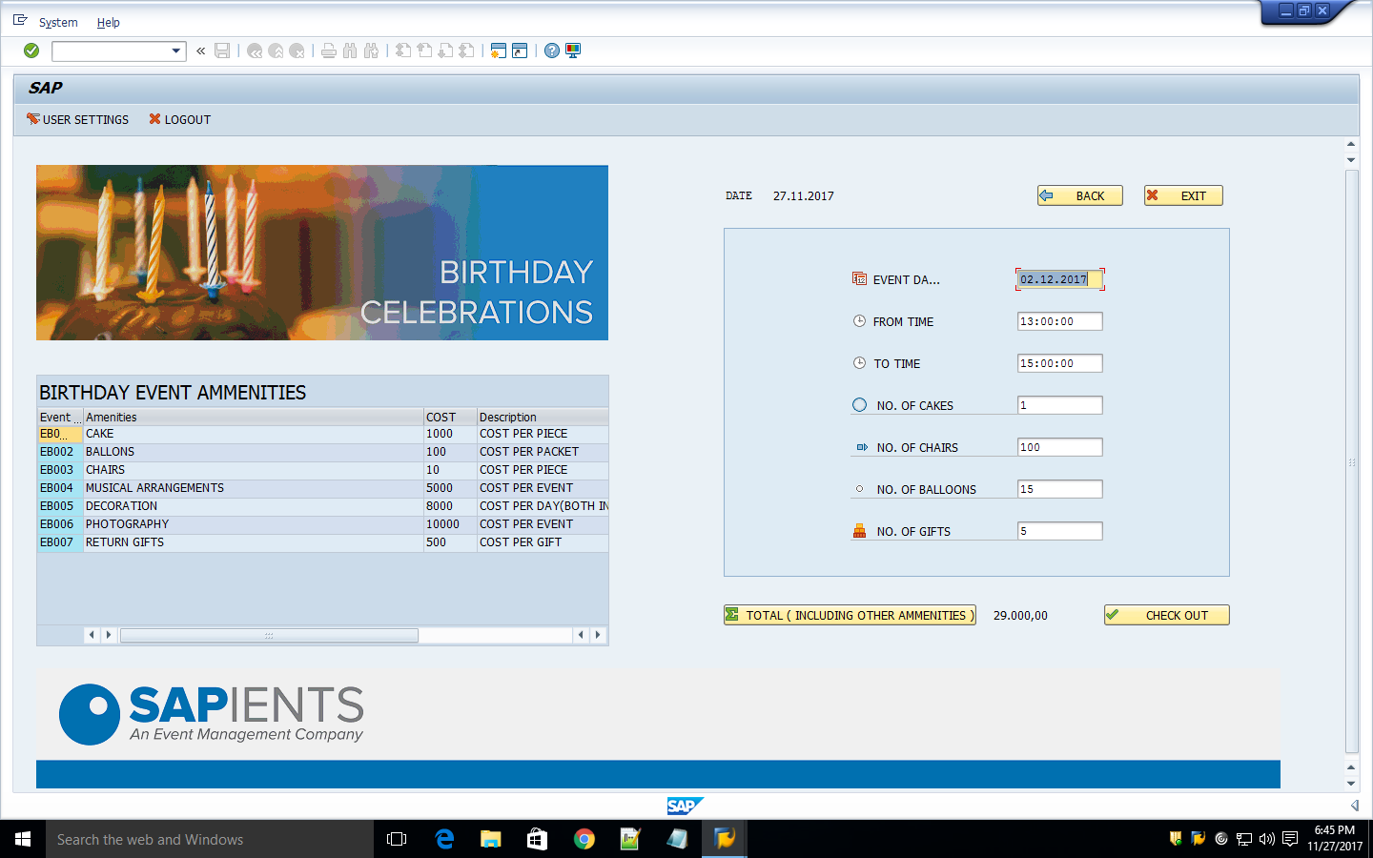
The above screen displays the birthday event screen. User can find the list of amenities and costs according to the amenities and the description of each amenity.
The user has to provide the event date on which he/she is going to host the event. From time and To time are also to be provided by the user according to the requirement.
Few customizations can be done by the user by selecting the amenities like No of Chairs, No of Cakes, No of Balloons and No of Waterpouches according to his/her choice. Once the user enters all this things, he/she can calculate the total amount which includes other amenities cost namely decoration, advertisement, photography and medical assistance.
The next step of the user is to click on the Checkout option for his/her details to be populated.

INVOICE SCREEN:
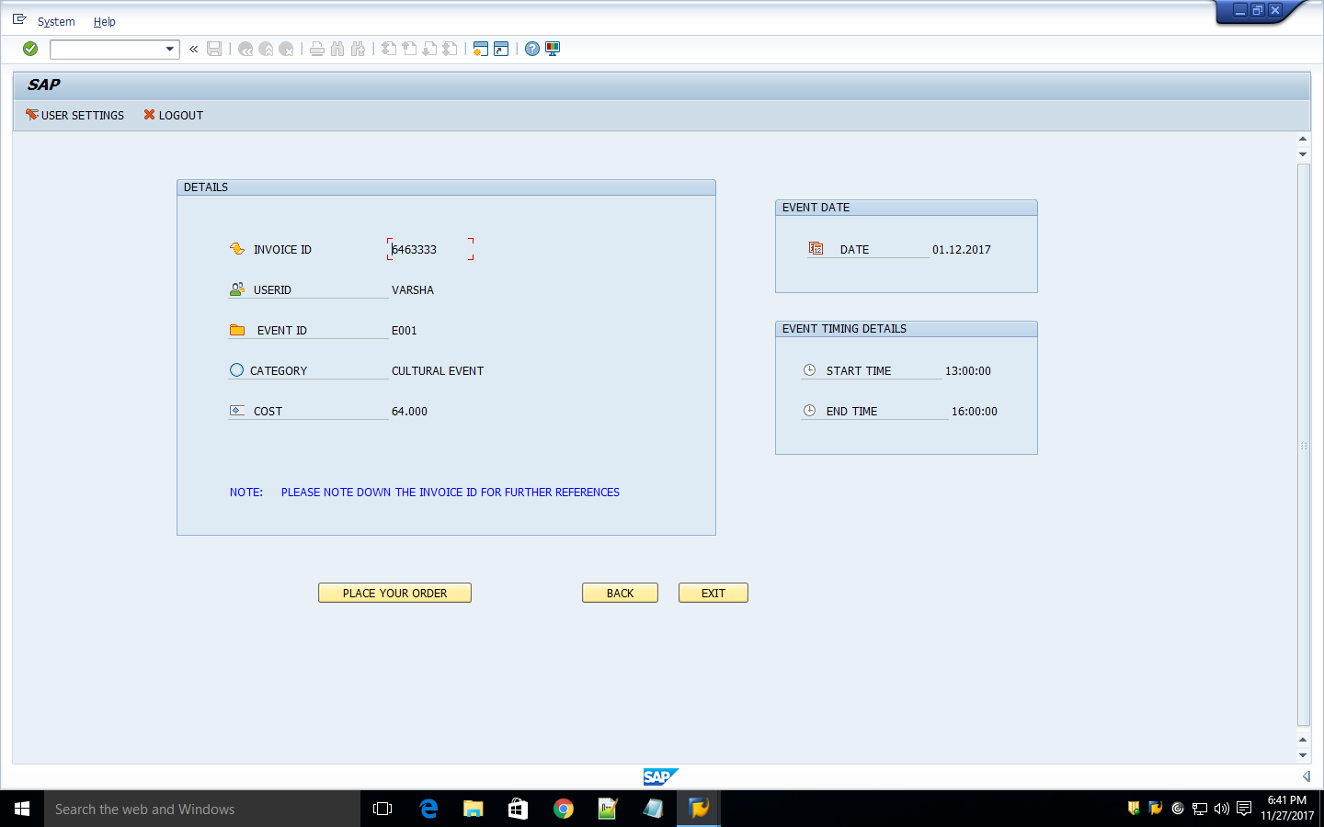

Once the user checks out with his/her event details, he/she will be redirected to this page and will be provided with the invoice id and can place the order by confirming his/her details.

MODE OF PAYMENT SCREEN:
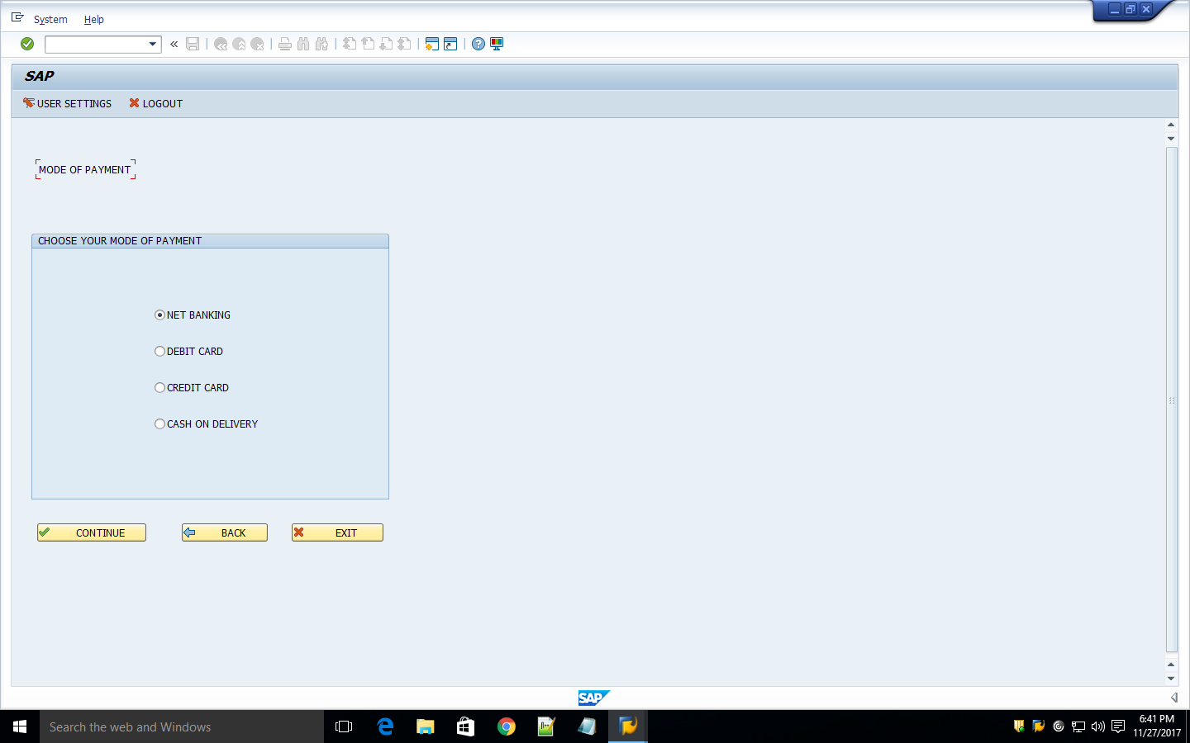

After confirmation, the user can do his/her payment in this application only. The modes of payment are four ways namely, Net Banking, Debit Card, Credit Card and Cash On Delivery.

NET BANKING VALIDATION SCREEN:
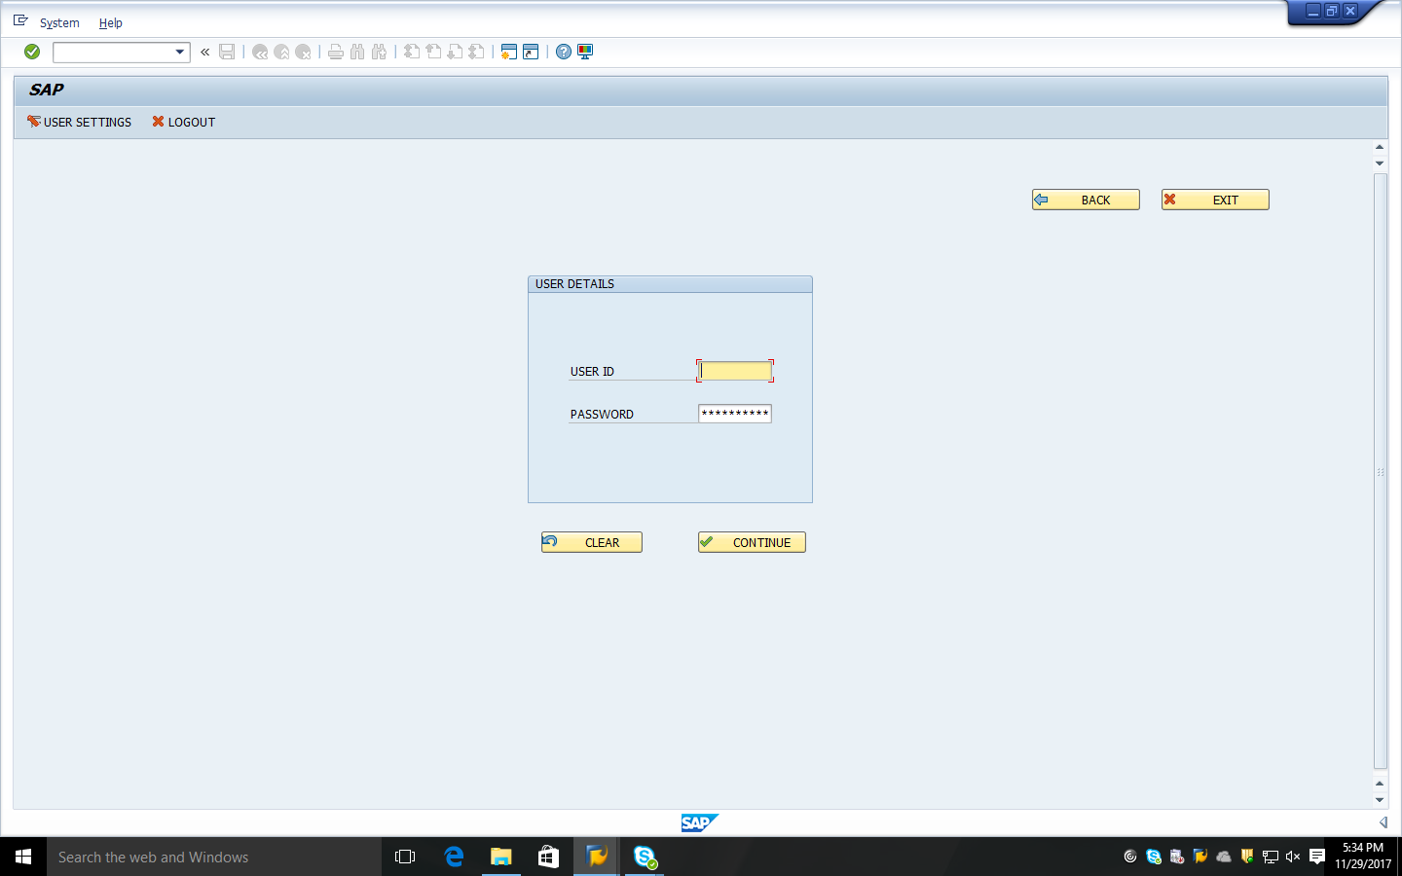

If user chooses the Net Banking option, he/she will be redirected to this page where he/she is validated with the credentials and proceed to payment.

TYPES OF BANK SCREENS:
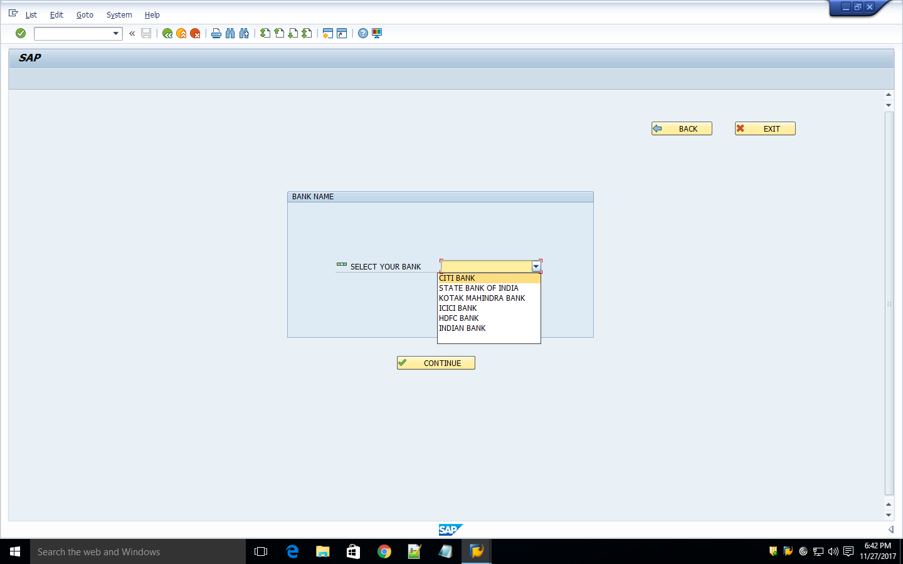

These are the banks we provided in the application in the mode of payment. User chooses his/her bank accordingly and click on “CONTINUE”.

CARD DETAILS SCREEN:
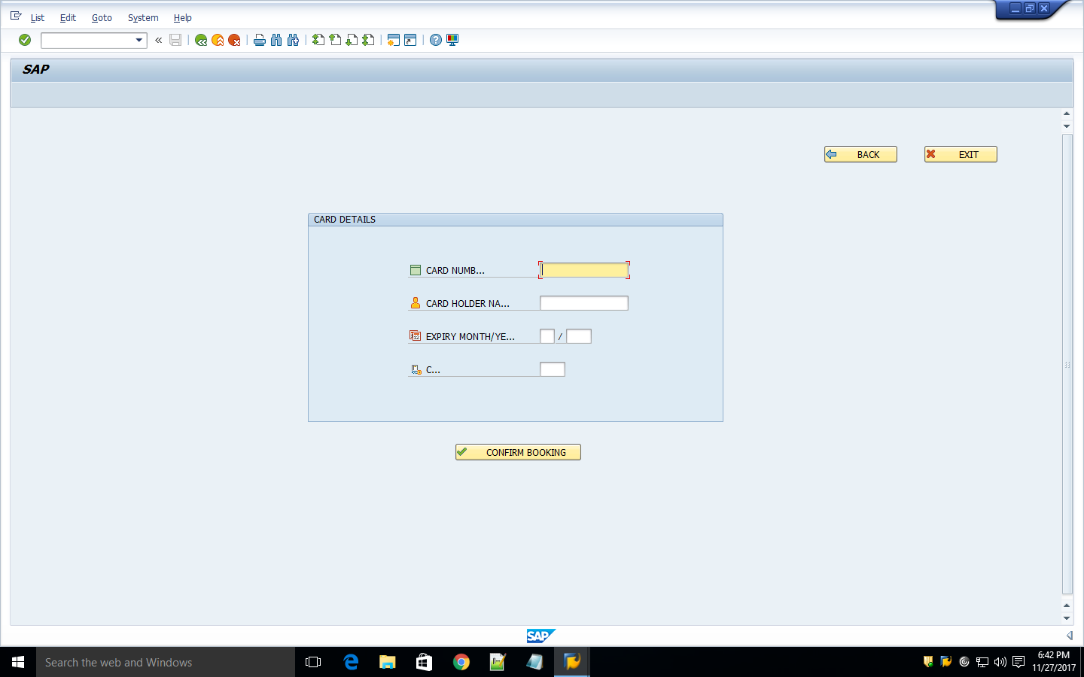

If the user chooses the Debit/Credit Card, he/she will be redirected to this page where he/she have to fill the details accordingly and confirm the booking.
FORM PRINTING SCREEN:
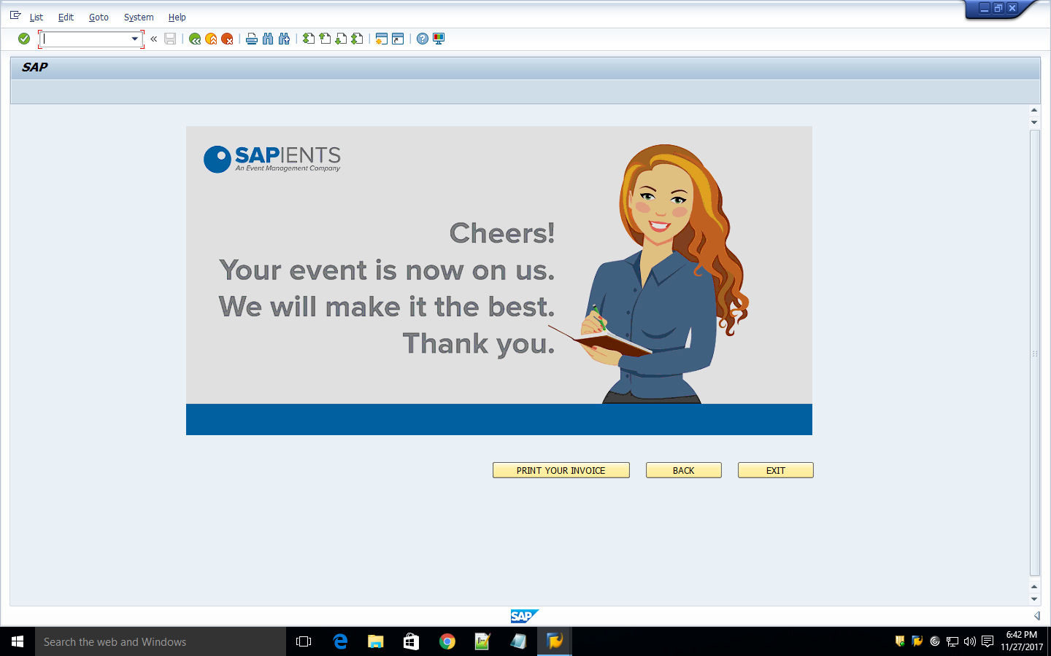

After successful entering of banking details or if the user chooses the Cash On Delivery option the he/she will be redirected to this screen where the user can have an option of Printing the Invoice.

INPUT PARAMETERS SCREEN:
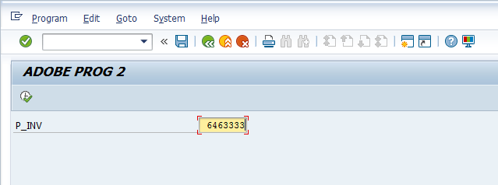

Invoice Id which is provided should be entered by the user here to print his/her invoice.

FORMS

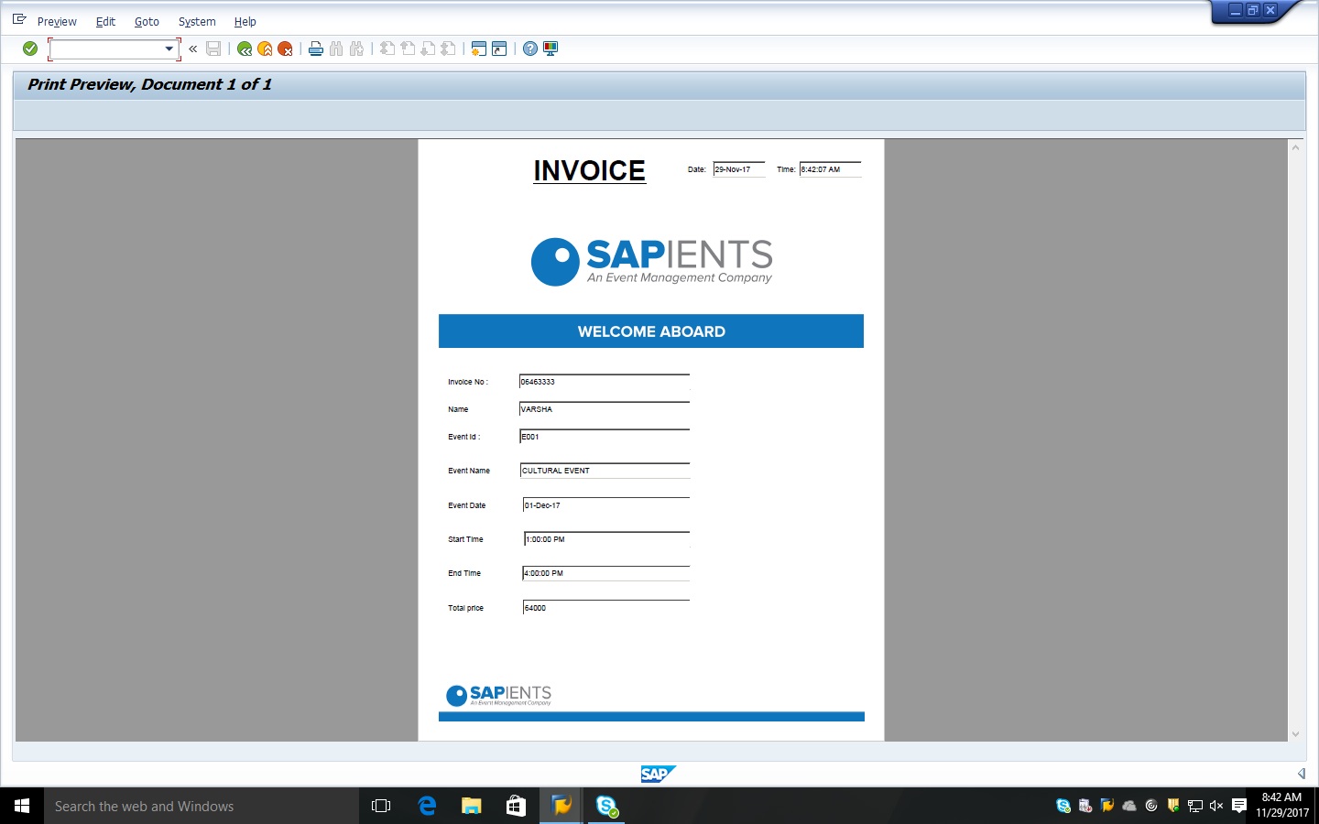

This is the final adobe form invoicr for the transaction.

ADMIN LOGIN SCREEN:
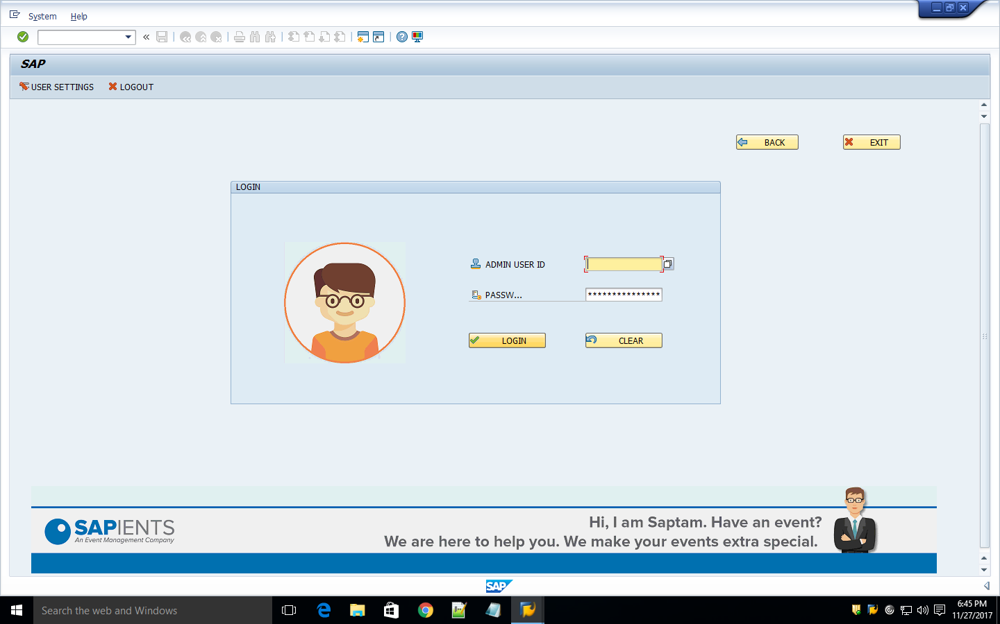

There is no registration for admin because login can be done only by authorized people.

ADMIN EDIT PROFILE SCREEN:
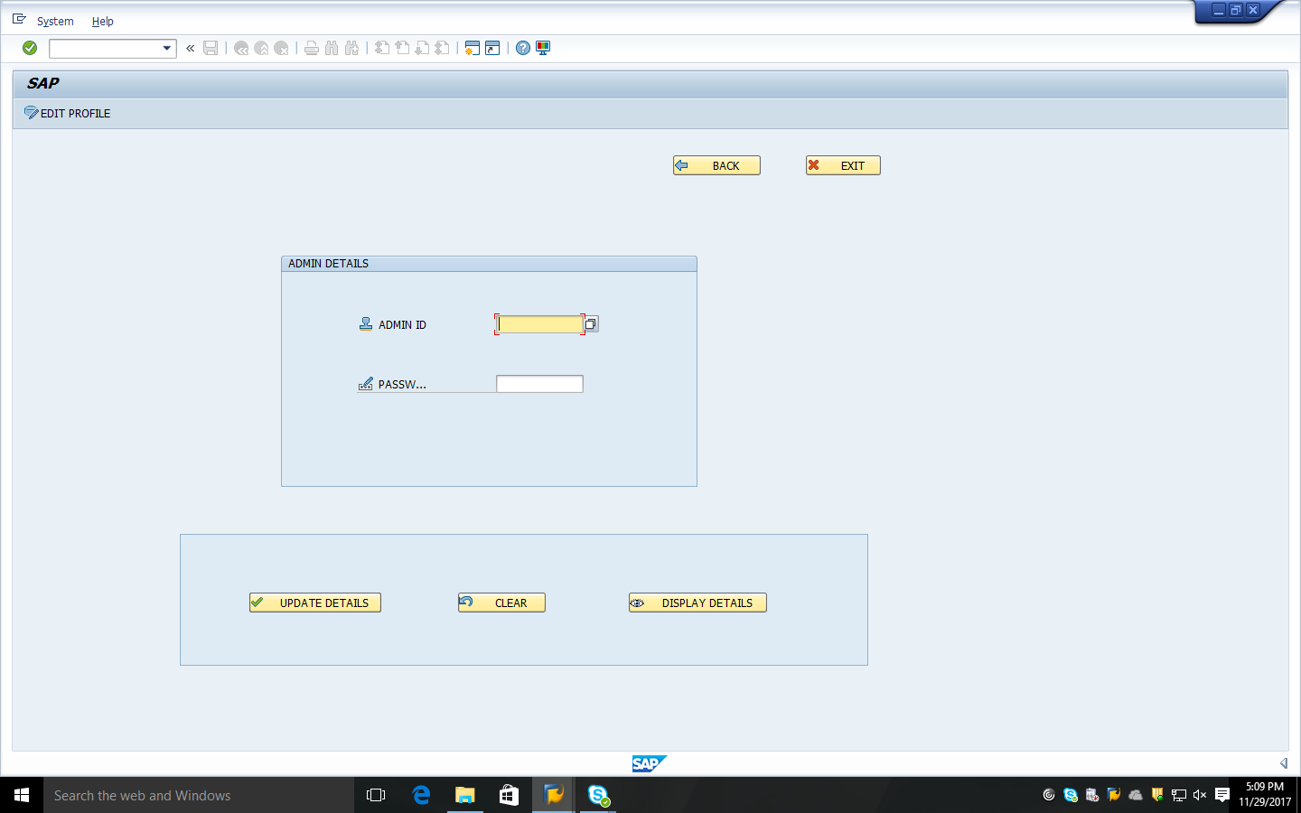
The admin can update the details and also displays details using the button “EDIT PROFILE”.

ADMIN SCREEN:
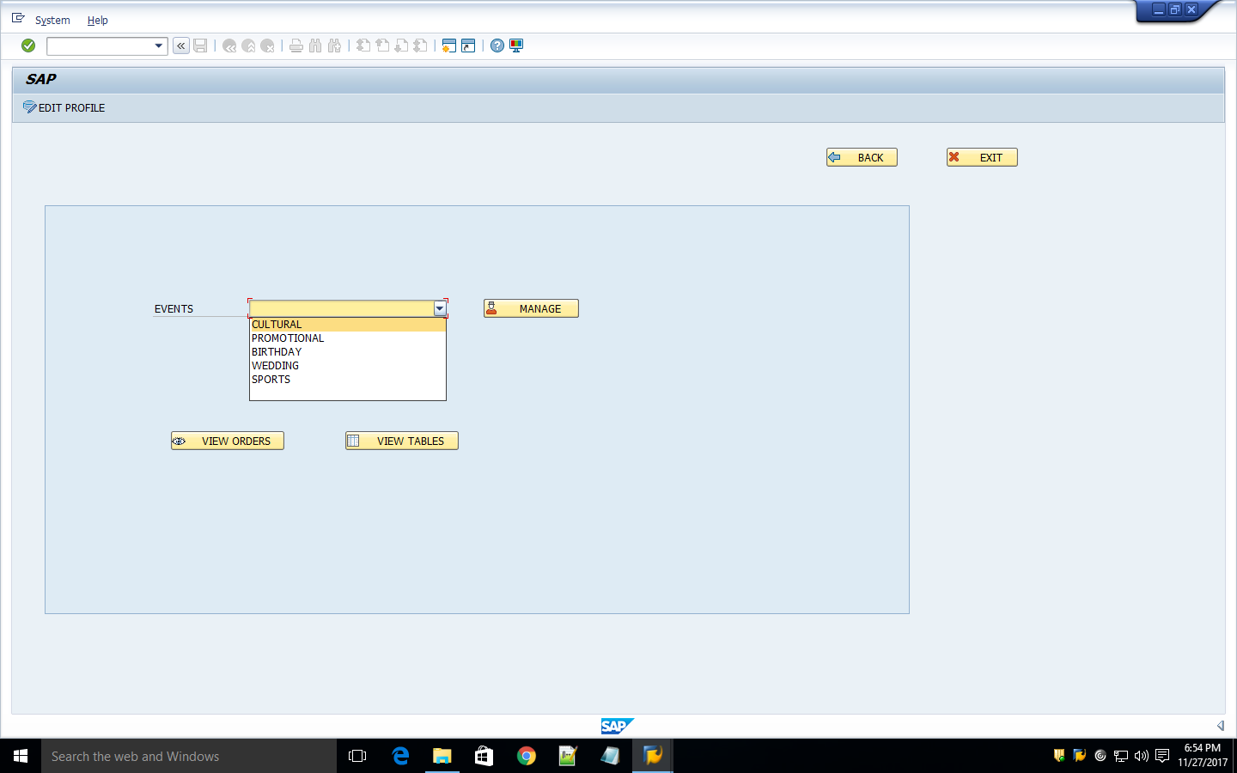

The functionalities done by admin are like managing events, track the orders and view tables.

CULTURAL EVENT MANAGING SCREEN:
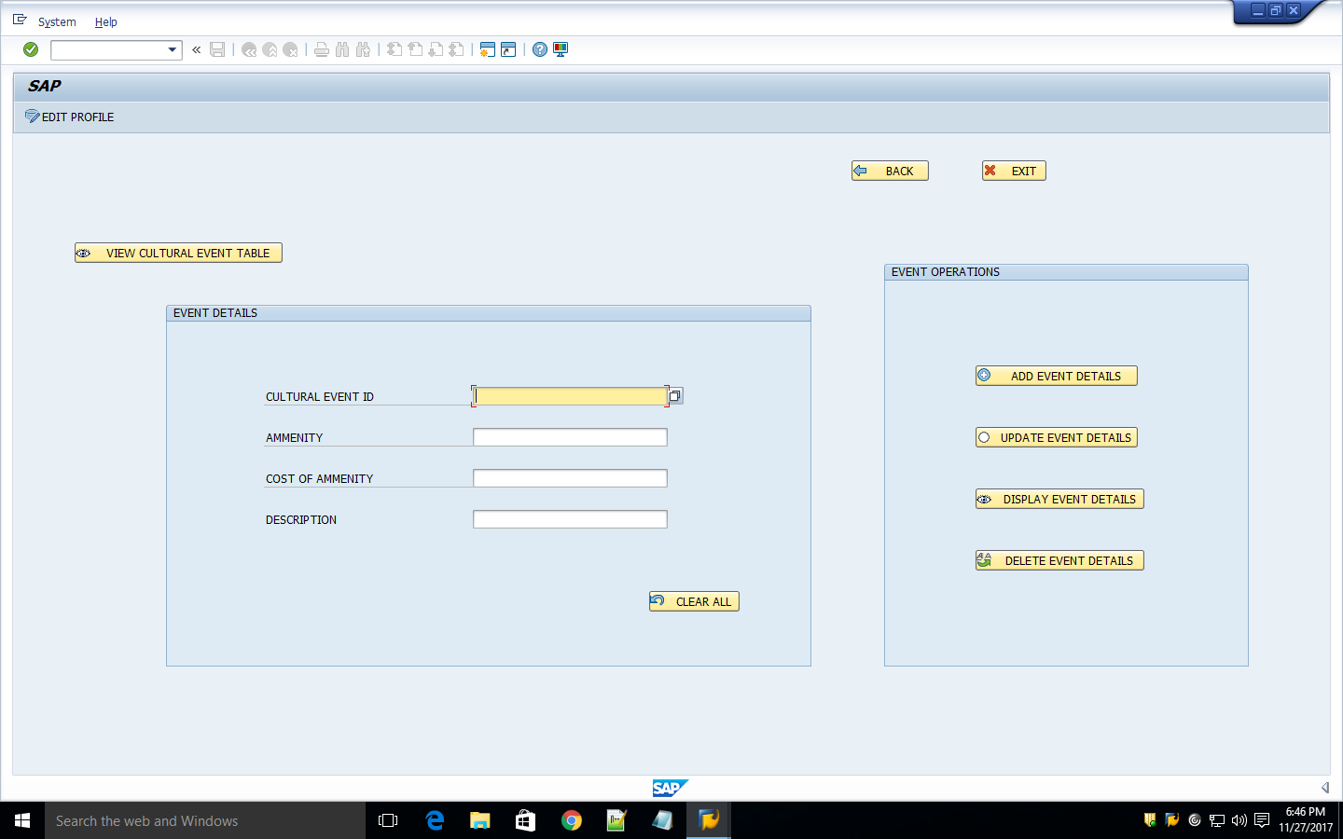
This is the screen for managing the cultural events like add, update, display and delete event details and he/she can also view the cultural event table by selecting the push button “VIEW CULTURAL EVENT TABLE”.

VIEW CULTURAL TABLE SCREEN:
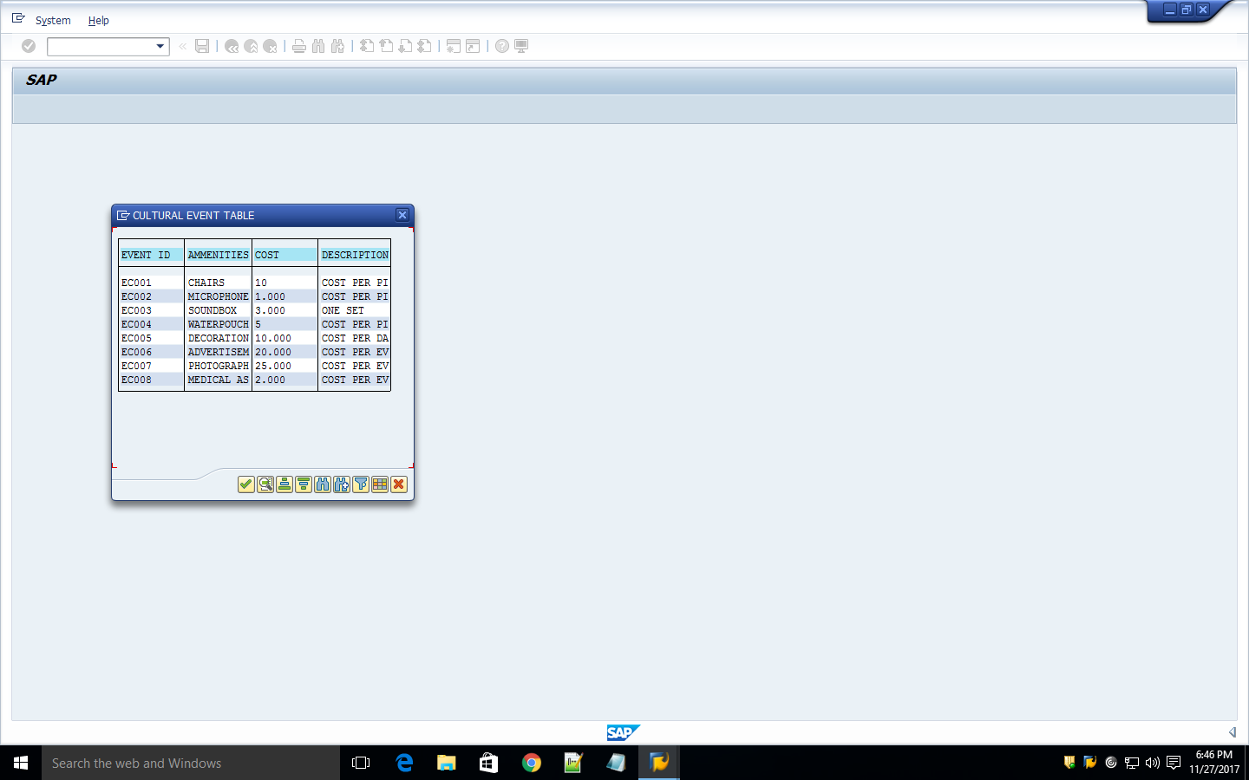

These are the contents of the cultural event table that is populated when he/she selects the push button “VIEW CULTURAL EVENT TABLE”.

PROMOTIONAL EVENT MANAGING SCREEN:
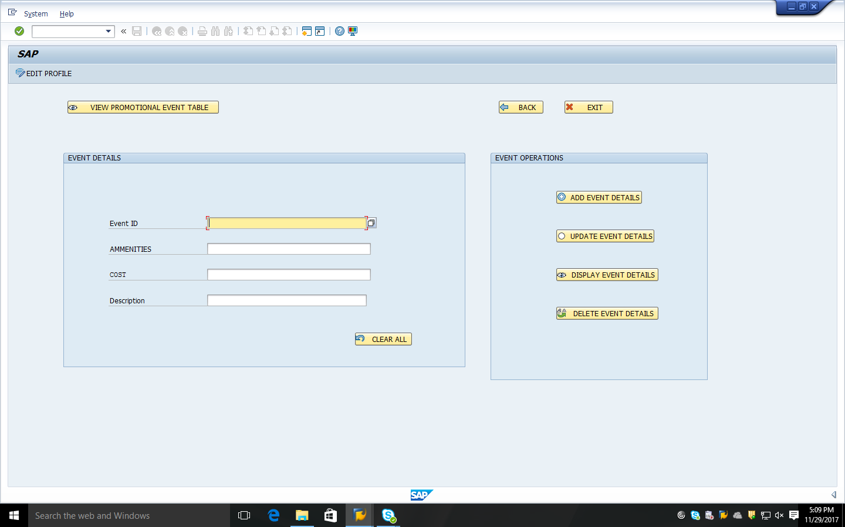
This is the screen for managing the promotional events like add, update, display and delete event details and he/she can also view the promotional event table by selecting the push button “VIEW PROMOTIONAL EVENT TABLE”.
VIEW PROMOTIONAL TABLE SCREEN:
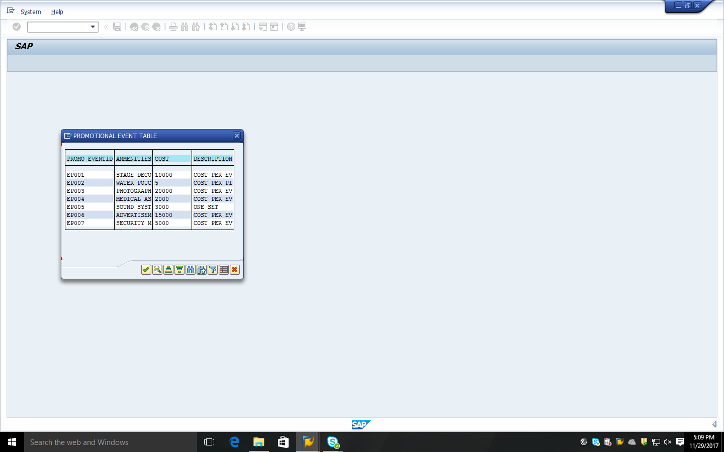
These are the contents of the cultural event table that is populated when he/she selects the push button “VIEW PROMOTIONAL EVENT TABLE”.

BIRTHDAY EVENT MANAGING SCREEN:

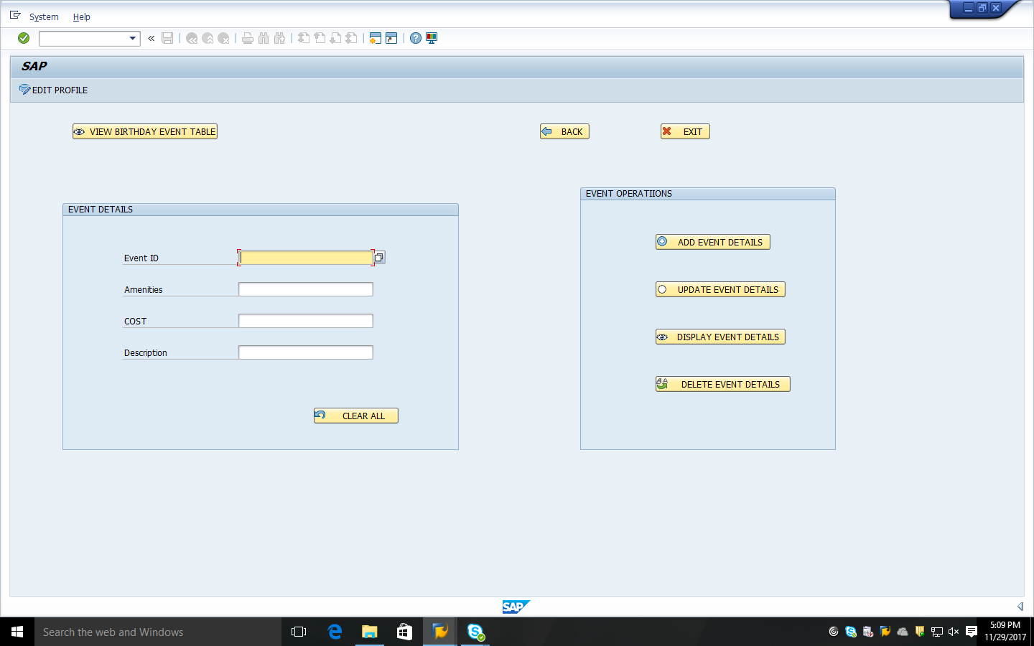

This is the screen for managing the birthday events like add, update, display and delete event details and he/she can also view the birthday event table by selecting the push button “VIEW BIRTHDAY EVENT TABLE”.
VIEW BIRTHDAY TABLE SCREEN:
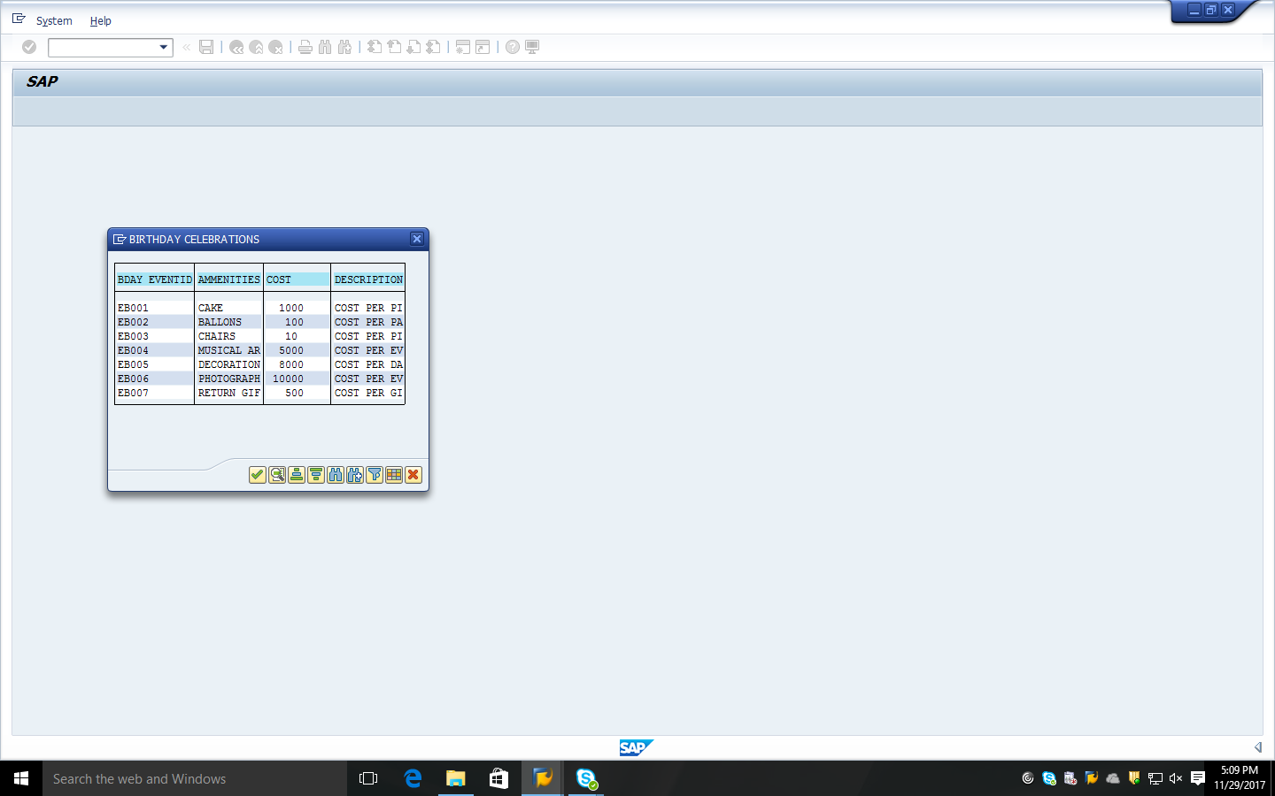

These are the contents of the birthday event table that is populated when he/she selects the push button “VIEW BIRTHDAY EVENT TABLE”.

WEDDING EVENT MANAGING SCREEN:
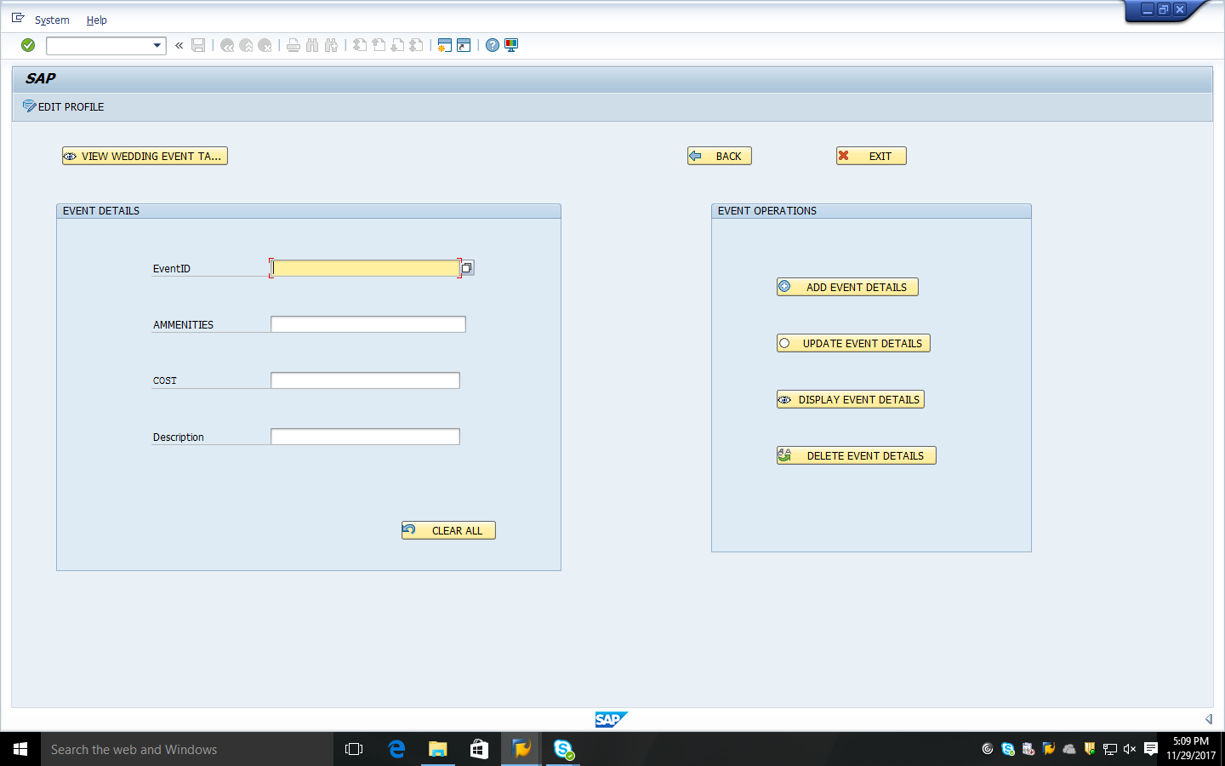

This is the screen for managing the wedding events like add, update, display and delete event details and he/she can also view the wedding event table by selecting the push button “VIEW WEDDING EVENT TABLE”.

VIEW WEDDING TABLE SCREEN:

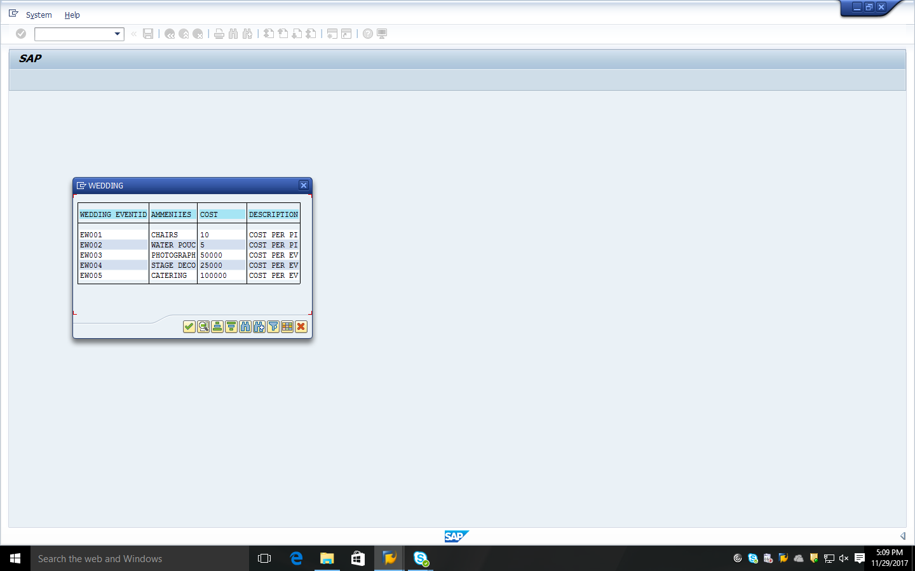

These are the contents of the wedding event table that is populated when he/she selects the push button “VIEW WEDDING EVENT TABLE”.

SPORTS EVENT MANAGING SCREEN:

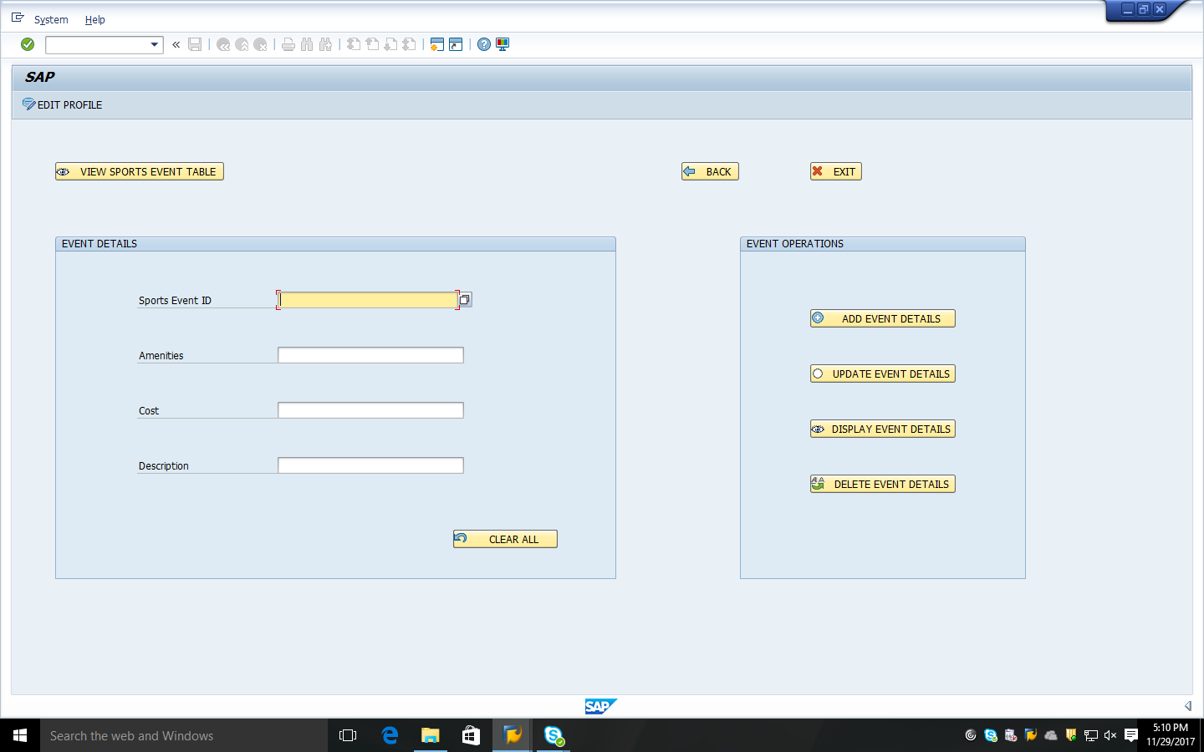
This is the screen for managing the sports events like add, update, display and delete event details and he/she can also view the sports event table by selecting the push button “VIEW SPORTS EVENT TABLE”.

VIEW SPORTS TABLE SCREEN:

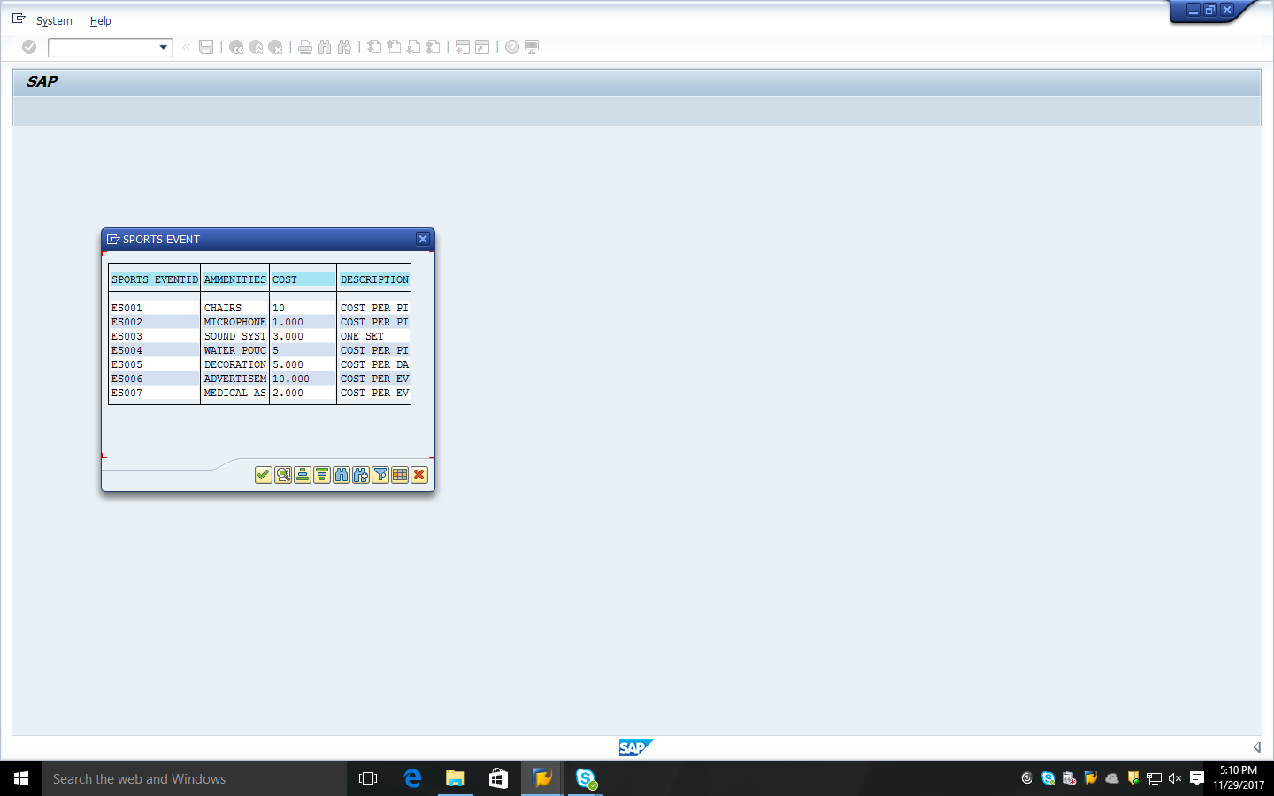

These are the contents of the sports event table that is populated when he/she selects the push button “VIEW SPORTS EVENT TABLE”.

TRACK ORDERS SCREEN:
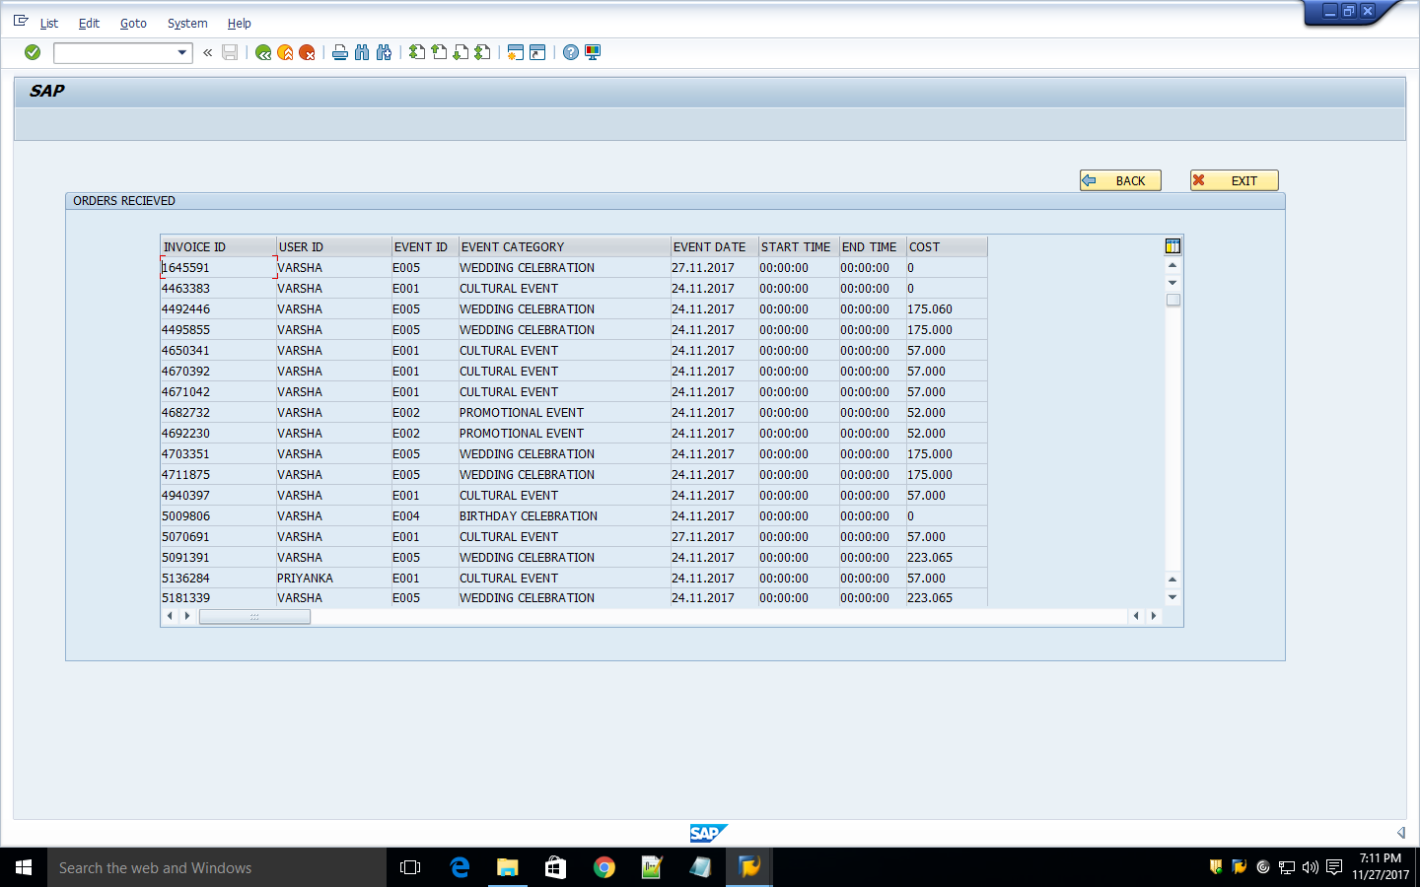
This is the screen which is generated when the admin clicks on “VIEW ORDERS”. This can help the admin to track the orders given by the different users.

VIEW TABLES SCREEN:
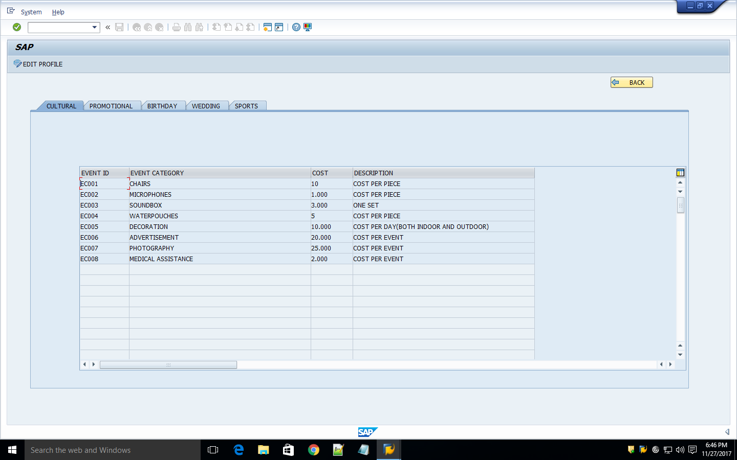
This is the screen generated when the user selects “VIEW TABLES” pushbutton. This helps the admin to view all the table contents in a single screen using tabstrip.

FUTURE EXPANSION:
- We need to provide the user with more events so that the application becomes more user friendly.
- We should provide a way show that the user can see their past record.
- We should provide a way to link the payment method to a payment gateway
Conclusion:
- Our project provides a platform for the users to manage their event in a well organized way.
- It also provides a better way of communication with the admin in providing services to users.
- Further enhancements can also be included to make it more effective.

